[Benjamin E. Mays High School]
Date: 3/3/2022
Time: 5:30pm
Location: Zoom Meeting

- Go Team Chair called meeting to order
- Quorum established
Role | Name | Present or Absent
Principal | Dr. Mulanta Wilkins | Present
Go Team Chair | Mr. Greg Clay | Present
GO Team Vice Chair | Ms.Lynnaya Rhodes | Present
Parent/Guardian | Ms.Kim Johnson | Absent
Parent/Guardian | Ms. Neltisha Monfort | Absent
Parent/Guardian | Ms.Trina Hughley | Absent
Instructional Staff | Ms.Sonja Lewis | Present
Instructional Staff | Ms.Leah Ervin | Present
Community Member | Ms.Tresa Jennings | Present
Swing Seat | Ms. Jennifer Tanner | Present
Student | Makeda Hailu | Absent
Student | Monteze Sutton | Present

- Action Items
  - Approval of Agenda (March 3, 2022) Motion Ms. Lewis/ Second Ms. Tanner
  - Previous Minutes (February 21, 2022) Motion Ms. Tanner /Second Ms. Lewis
  - Presentation:
DATA
Address budget concerns
GO TEAM Office member -Ms. Gibson -Present
lV. Discussion Items-Dr. Wilkin’s presentation:
- Performance Measure Based on Smart Goals
- Student Population -Enrollment trends student population has increased
- Student Academic Success-August 21-Dec. 2021 –increase in the last 3years
- MAP Data-Math & Reading -lower than district average but has increased in growth, 2nd highest in district
- HOPE Eligibility- 2018-2021- increased
- Master Teacher Leader Support- PLC Support from instructional coaches and master teachers
- Decrease Suspension-2.53-2.35
- BESS DATA-helping hands and Family ties
- One Fourth being served -Rational for additional Clinical Therapist
- Rational for additional SELT over 180 SPED Students
- Three Budget Options 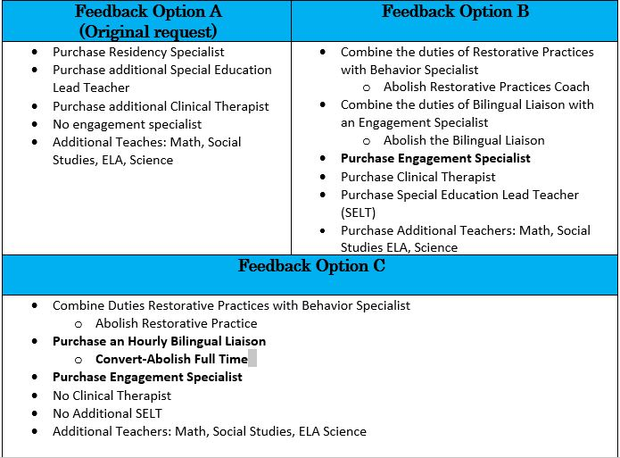
- 5 GO Team members voted YES for Option B, 1 member voted NO, 1 member abstained
- Votes reflected Option B as New Budget

V.
Information Items
Chair Clay stated that Family and Community engagement will be on agenda for next meeting
Dr. Wilkins invited Keisha Copeland from the district has been invited to March 10th meeting.
Next GOTEAM Meeting Thursday, March 10, 2022, at 5:30pm

VI. Adjournment: Motion Ms. Tanner seconded Ms. Lewis (passes)

